Laporan Praktikum 3



|  |
| --- |
| Disusun Untuk Memenuhi Tugas Mata Kuliah Web Programming 2 |
| Nama : Denis Oktaviano  NIM : 18090135  Kelas : 5C |

**PRODI D IV TEKNIK INFORMATIKA**

**POLITEKNIK HARAPAN BERSAMA TEGAL**

1. Source Code

view-form-matakuliah.php -> application/views

view-data-matakuliah.php -> application/views

Matakuliah.php -> application/controllers

1. URL

<http://localhost/pustaka-booking-denis/matakuliah>

<http://localhost/pustaka-booking-denis/matakuliah/cetak>

1. Capture Output Program

* view form

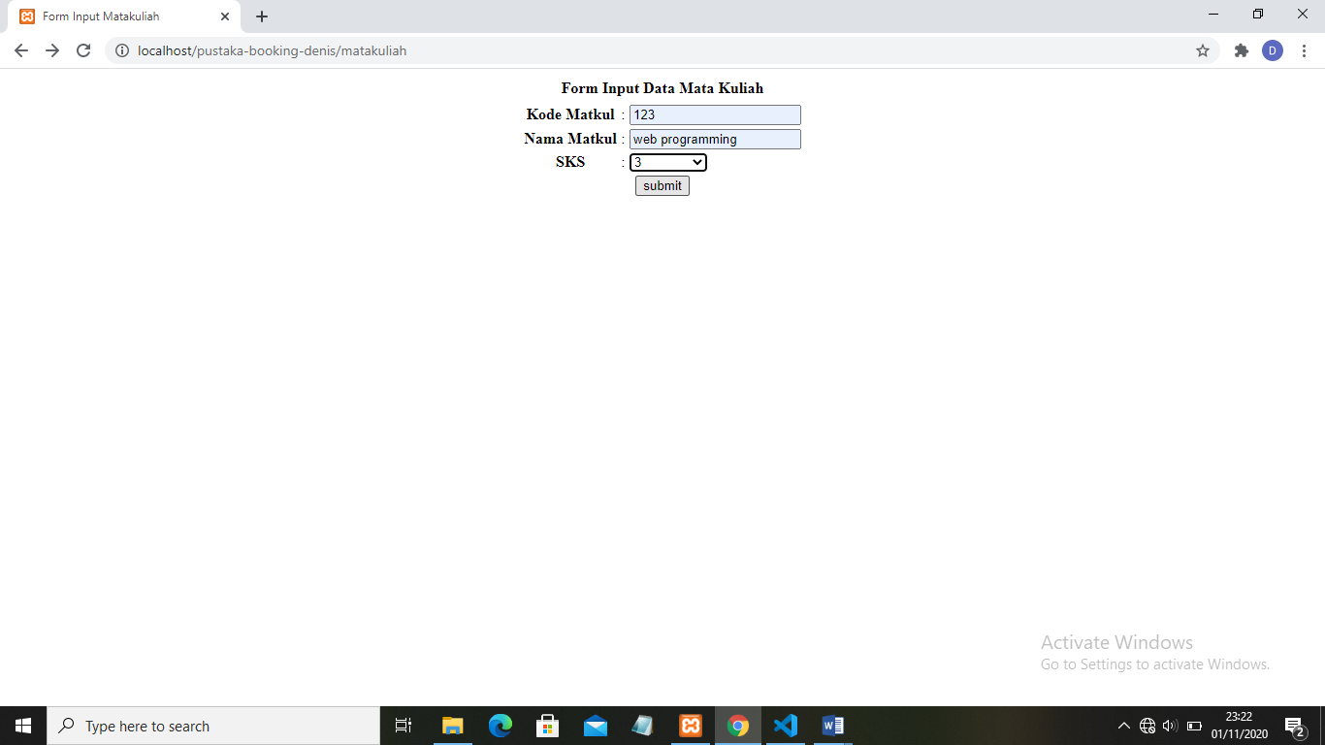

* view data

